To share your notebook, Select the icon on the top right a marked in red in the image below.

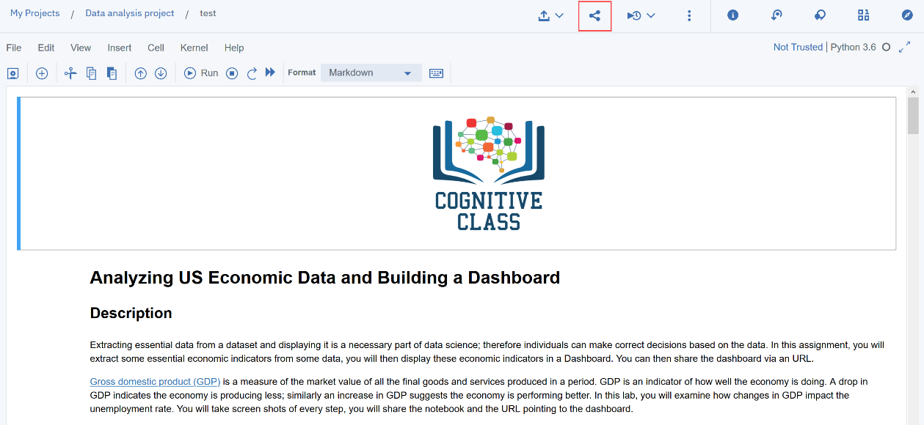

A dialogue box should open, select the option all content excluding sensitive code cells.

